**Reconstruction**

Fast tomography of battery failure is performed using a specialized synchrotron-adapted setup. The incorporated rotation stage and the high-speed detector that enables fast CT, are not directly linked. To overcome this issue and enable CT reconstruction, the rotation angles are accessed using a fast Transcom recording of the motor positions. The angular positions are then synced with the projections and saved in a NeXus (.nx) file format, such that each projection is attributed with the correct rotation angle. The angles are recorded and saved in a .txt file, that in the first part of the code is read and cut to match the projections, each saved as .tiff files. Codes for this are found in the folder *Reconstruction*.

**In the main, please provide:**

main_folder = the main folder to data. Later on, it is possible to loop through several experiments or select specific experiments to be processed, therefore provide only the main path here.

path_dark = path to where the dark images are located

path_ref = path to where the reference images are located

flag360 = **True** for reconstruction every 360 degrees, and **False** for reconstruction each 180 degrees.

pixel_size = Give the pixel size in [m]

energy = Give the X-ray energy in [keV]

distance = Give the sample/detector distance in [m]

In the following step, CT reconstruction is done from the .nx file using the ESRF-developed software (find Documentation here: (<https://gitlab.esrf.fr/tomotools/nabu>)to obtain the 3D volumes. This algorithm pre-processes the projections through normalization using flat and dark-field images, then reconstructs using the FBP-reconstruction algorithm incorporated in Nabu. Paganing filtering is applied in the reconstruction step to increase the image quality.

**Reslicing**

In a primary step to achieve faster processing of large 3D datasets, the CT volume is horizontally resliced for every degree from 0-180. See step A in the figure.

**Registration**

**Speed Mapping and Plotting**

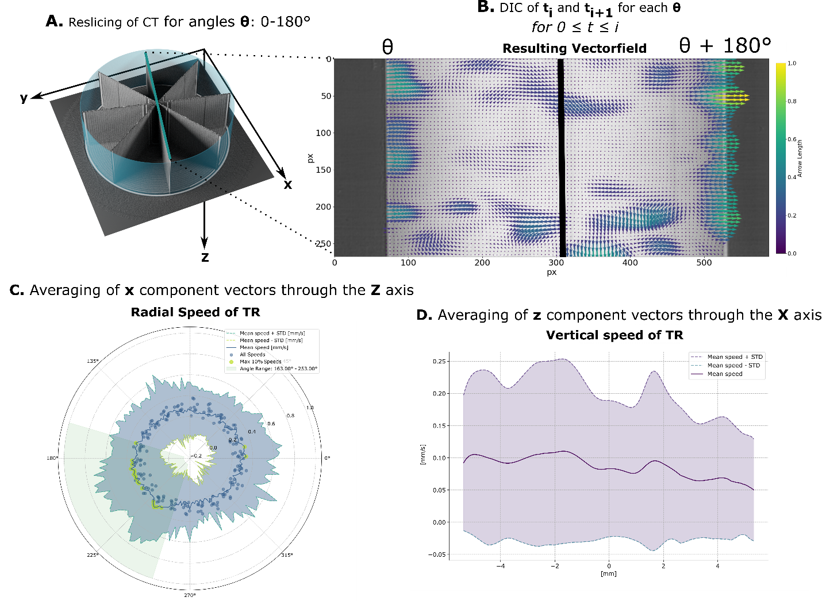

Resliced datasets from two subsequent time steps at the same angular positions are thereafter considered in pairs for the registration process, see step B in the figure.